**Programs**

Programs: **School: Students: Free to Learn Our Way:**

Free to Learn Our Way began with an idea of a world, a vision of kinder kids, emotionally learned beings, socially inclusive students with a sense of community spirit, humane communication, happier folks, facilitating We(s) in the world of I(s) and of people in touch with their inner world with all of its landscapes, flowers, dreams and power. Our purpose is to facilitate a space for children where they are free to learn their own way.

**Free to Learn Our Way** intends to:

* Give the students a space to explore 10 different areas of learning and life skills with 10 different modules that can very well be integrated in their educational journey.
* Focus on experiential hands on learning as the cornerstone of the entire program.
* Evoke responses from the students over statements made, making the teaching a 2-way process.
* Nudging the students to self-reflect on the teachings by exploring and developing insights. This in a way helps them to find an anchor within themselves.
* Encourage students to explore their emotional and social selves.
* Ensuring smooth delivery of the program by well-inducted Flow trainers assigned to the school called ‘Flow buddy’.
* Empowering the students with tools and models that they can carry with themselves for life like Johari Window and Drama Triangle to name a few.
* Focus on transforming the classroom into a safe space to share and learn through practices like a sharing circle, group discussions and Think Pair Share (TPS) to name a few.
* Complement the existing framework of holistic education by a program module created by research of over 1 year.
* Facilitate the process of empowering students to be better and whole human beings.

Our student modules have been structured on the basis of the framework of Lev Vygotsky’s learning theory on ZPD (Zone of Proximal Development), wherein all the modules have been created keeping in mind the most immediate [psychological development](https://en.wikipedia.org/wiki/Psychological_development) of learners that includes a wide range of their emotional, cognitive, and volitional psychological processes. Our trainers’ modules have been designed with a learner centric approach through Scaffolding which provides the students with a significant ‘More Knowledgeable Other’ (MKO) in order to guide them to reach their full potential to understand all the nine modules.

**Our Approach: AIR**

Whilst the skills acquired through academic study are in constant use, it is possible for the concepts learned to sometimes exist in the mind alone if not applied and experienced, where they can eventually cease to exist.

Free to Learn Our Way is different, as it relates directly to experiences that students will have in their everyday lives. It is possible to teach all about the concepts that we have created in our program to students, but that would be to miss the point. We believe that the teaching must have experience as its primary aim: we should be teaching the students not just ‘to know’ but also how to be and to do.

In order for this to work, we have to get the students to experience it. Our approach helps us to do it, which is:

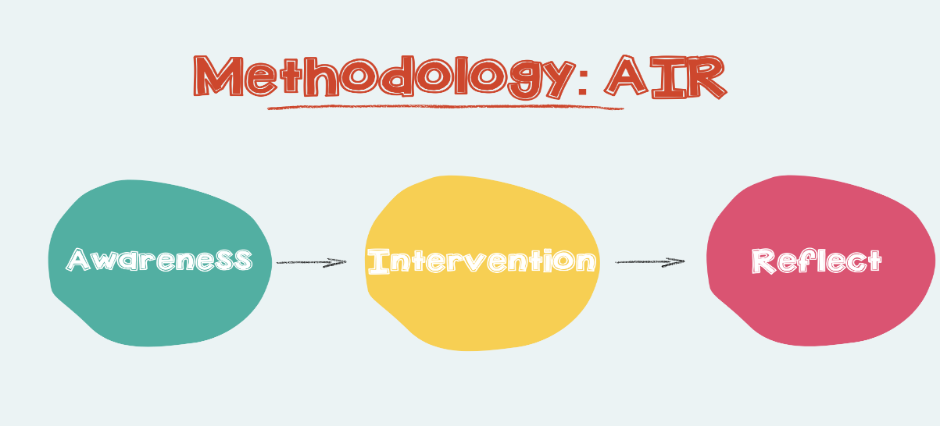

**Awareness(Notice) –> Intervention(Act and experience) –> Reflect (Self Evaluation)**

**AIR**

**How will we do it?:**

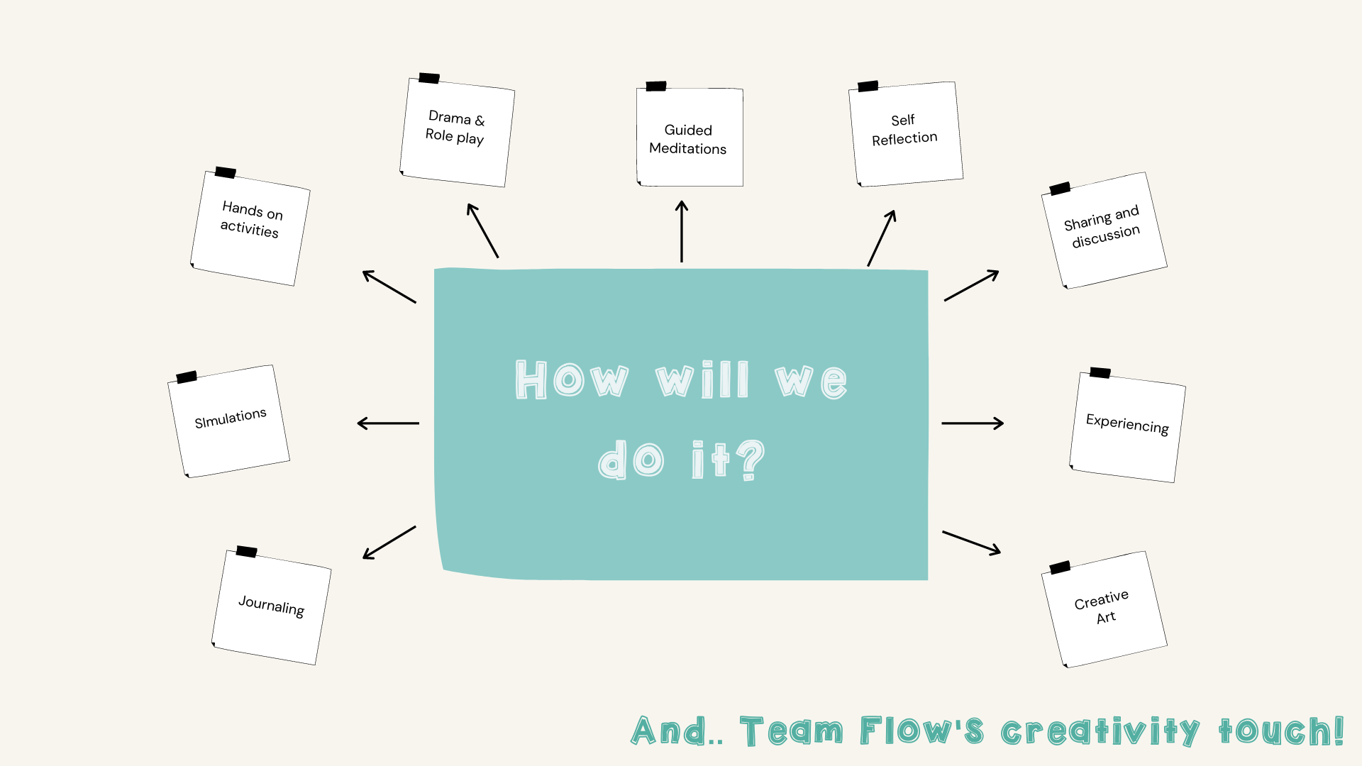

**How to collaborate?** (Ref <http://www.blueorbfoundation.com/poornata.html>)

Get in touch with Team Flow – Have a look and feel of the program – Sign up for the program – Trainers are assigned, Students kits are delivered - Program begins! – Submitting monthly reports and bytes – Conducting classroom observation visits by Team Flow – Submitting Annual Report

Why wait? Contact us for a visit to your school for a demo of our program.

Programs: **School: Teachers: WOLF Workshops on Learning and Facilitation**

‘WOLF’ is a mirror image of ‘FLOW’ as students are a mirror reflection of the teachers that tutor them for Life.

We at Flow, have focused on addressing both the sides of the coin. While we cater to the needs of the students to help them grow up to be reasonable and compassionate individuals, we have also given an equal amount of thought into supporting the ‘Teacher’, who is the ‘WOLF’ that leads the pack.

Our Teacher’s Training Program envisions:

* Sensitising teachers to a purposeful teaching approach by exploring the key role they play in shaping the students.
* Facilitating sessions and activities to explore how teachers can have an edge in planning, assessing and delivering their sessions
* Capacity building not merely at a professional level but also at the personal front with tools to better manage their personal lives. After all happy teachers change the world!
* Equipping them to better manage their relationships with the students of the 21st century.
* Lots of learning, re-alignment and ‘Aha’ moments as the WOLF leading the pack of the next ambassadors of our planet.

What is the structure?

Workshops on Learning and Facilitation has been designed on the 3S module concept. Teacher training program includes activity-based workshops on sub themes under the 3 umbrella modules which are:

The Full WOLF program comprises a pack of 10 workshops under the 3 modules. Together we analyse the needs of the school from a teacher’s perspective and then pick and choose modules from the list of 10, that suits the needs of the school.

**How to collaborate? (Ref: http://www.blueorbfoundation.com/teachers-training.html)**

Get in touch with Team Flow – Have a look and feel of the program –Decide on the workshops from our 10 workshops plethora -Sign up for the program –Program begins and runs through entire year with takeaways and handouts! –Conducting classroom observation visits by Team Flow – Submitting Annual Report

Why wait? Contact us for a visit to your school for a demo of our program.

**Mock event**

Sample draft of the mock event:

**Free to Learn Our Way Program Launch**

**Venue:  TBA (Jagdalpur)**

**Date: 6th February 2021**

FLOW invites all the principals and coordinators of all the renowned schools of Jagdalpur to experience the program and get a glimpse of the journey that we are to embark on. FLOW began with a question, ‘What was something that was not a part of my education, but I wish it was!’, and from then on, we are constantly striving to serve the future generations by adding every possible element of life that is of utmost importance.

FLOW does not only cater to one side of the coin, which is why we have also addressed the needs of the facilitators through the WOLF initiative program (Workshop on Learning and Facilitation) which is a mirror image of ‘FLOW’ as students are a mirror reflection of the teachers that tutor them for life.

The WOLF initiative program was created with an intent to provide the teachers an underpinning insight about purposeful teaching methods, soft skills development, lesson planning, phonetics, and work-life balance etc.  We assure you these sessions cover just the tip of the iceberg.

The entire team at FLOW will be honored by your presence and we sincerely await your arrival. To get in touch with us and be a part of our program launch, kindly register at the link given below: